**Group 5**

***Will, Luis & Kyle***

**Proposal**: News Scraper

We will be scraping the top 10 stories from our news sites (see below) and tagging them based on the type of news story it is (world, US, economic, COVID-19)

**Websites**: cnn.com, cnbc.com, npr.org

**Database Design**: *(see below)*

**Columns**: *(see below)*

**GutHub Repo**: <https://github.com/IILuisII/ETL_Project>

**Sources**: <https://npr.org>, <https://cnn.com>, <https://cnbc.com>

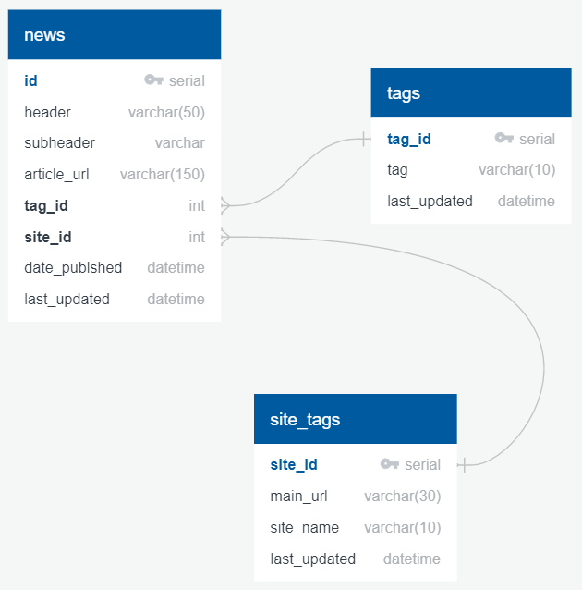

*\*\*The “site_tags” and “tags” tables will be static and the “news” table will be live*